**Introduction to Express Js**

Aj theke nodejs er ekta popular framework express js niye kaj kora shuru korbo. 2010 shale TJ Holowaychuk name ekjon programmer nodejs niye etar upor kaj kore express js create koren. Porobortite express js ke acquire kore ney strong loop name ekta company. Erpor IBM 2015 shale strong loop ke acquire kore ney.

Express js in the back end nodejs runtime kei use kore. Express js er kichu built in support ache. Express js jekono web application kingba backend server banate capable. Eta diye MVC (Model View Controller) pattern use kore kaj kora possible.

Express js simple ekta framework. She just tar dorkari jinishta niyei concerned. Ekta backend web application ba rest api develope korte hole amader muloto request accept kora lage. Ebong response deya lage. Request analysis kora, process kora ebong response deya --- er theke beshi kaj korte jawar dorkar nai. Express amader ekhanei help kore. Express js er purpose hocche raw nodejs er overwhelming syntaxgula ke khanikta abstract kore amader jonno more human readable framework deya. Request handling er shomoy express js middleware name ekta concept use kore. Eta bujhle express js bojha easy hoye jay. Express bujhte gele 5 ta jinish valo moto bujhte hobe.

1. Express() function ta
2. Express() function call kore dile je application object ta pai sheta
3. Request object
4. Response object
5. Ekta routing system ache jate ekta application er bivinno route e hit korar jonno sheta use korte pari.

Ekhane request ebong response object ta muloto nodejs eri request ebong response object. Express just shegula ke inherit kore extend kore nise ebong extra kichu property ba method add kore nise.

Express js light-weight, simple ebong ekta jinish niyei focused.

Ekhon express js er practical usage dekhbo. Ekta folder khule tate index.js name ekta file nilam. Erpor terminal e npm install express kore express package ta ken iye ashlam.

Index.js file ‘express’ module ta ke require kore niye ashlam ebong ‘express’ name ekta variable e sheta nilam. Ei ‘express’ variable ta ekta function. Ekhon const app = express() kore function ta ke call kore dilam. Ekhane ‘app’ hocche ekta object. Ei object ta amader shob rokomer convenience dey. Raw node js e server create kore server.listen(3000) use kortam. Express e app.listen(3000) kore 3000 port e listen korte parbo. Shei shathe listen() method e ekta callback function diye dite parbo. Callback function e bole dibo listen complete howar por console e ki print korbe.

Echara raw nodejs createServer function er callback e req, res diye bole disilam req er kon url ki response dibe ba kon method e ki response dibe. Express js eo server start korar shomoy egula define kore dite parbo.

For e.g. app.get(‘/’,(req,res)=>{res.send(‘this is home page’)})

Etar ortho user jodi get request kore “/” url e tahole callback function ta execute hobe. Ei req, res nodejs er req, res er extended form. Ei send method ta nodejs e nai.

Index.js …

*const* express = *require*("express");

*const* app = *express*();

app.*get*("/", (*req*, *res*) *=>* {

  res.*send*("This is home page");

});

app.*post*("/", (*req*, *res*) *=>* {

  res.*send*("This is home page with post request");

});

app.*listen*(3000, () *=>* {

  console.*log*("Listening on port 3000");

});

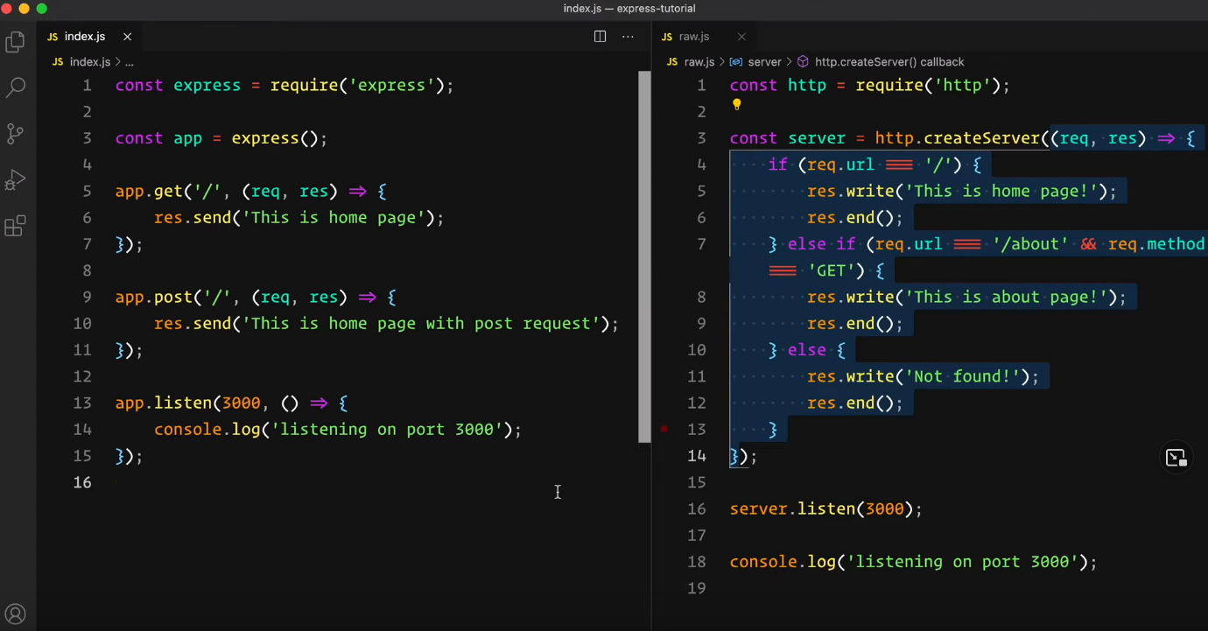

Ekhon output check korar jono terminal e ‘nodemon index’ ba ‘node index’ likhe enter dilam. Postman e get method e localhost:3000 e gelam. Then post method e gelam. Expected output pelam.